Trouble Logging In email

Lost Password Instructions
I’m sorry you are having trouble logging in to your Puberty: The Wonder Years curriculum account.
Please follow these steps:
- Go to https://pubertycurriculum.com/
- Click “Teacher Login” at the top.
- Click on “Log in”
- Use the “Lost your password?” feature as needed.
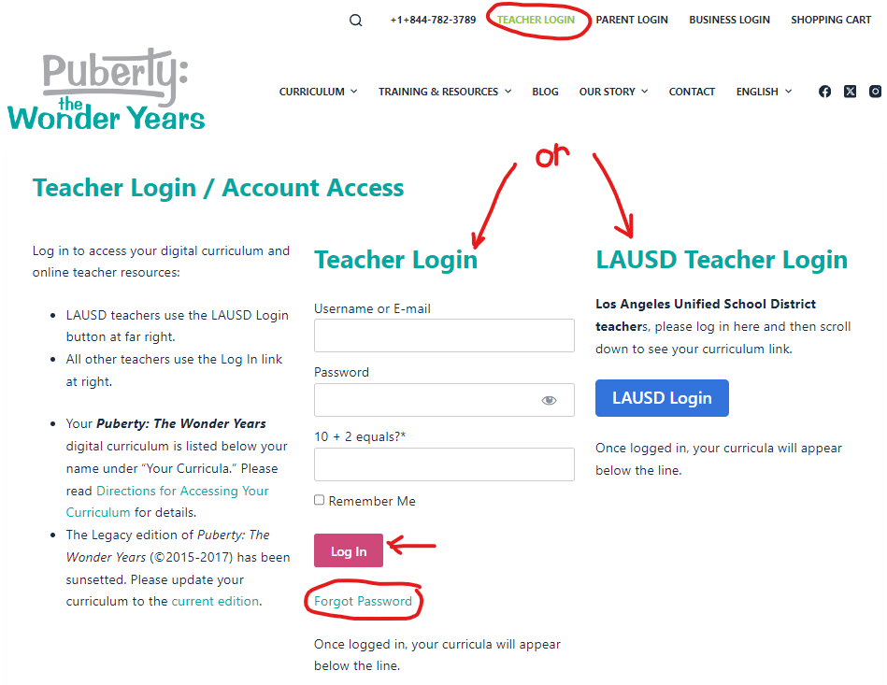
​Please let me know how it works. Thank you, _______

